ABOUT AMY CARNEY

Amy Carney is a Leadership Parenting Coach, Speaker, Author and Freelance Writer.
Amy started her company, Parent on Purpose, to create content, products and events to better equip and empower moms and dads during the season of full-time parenthood.
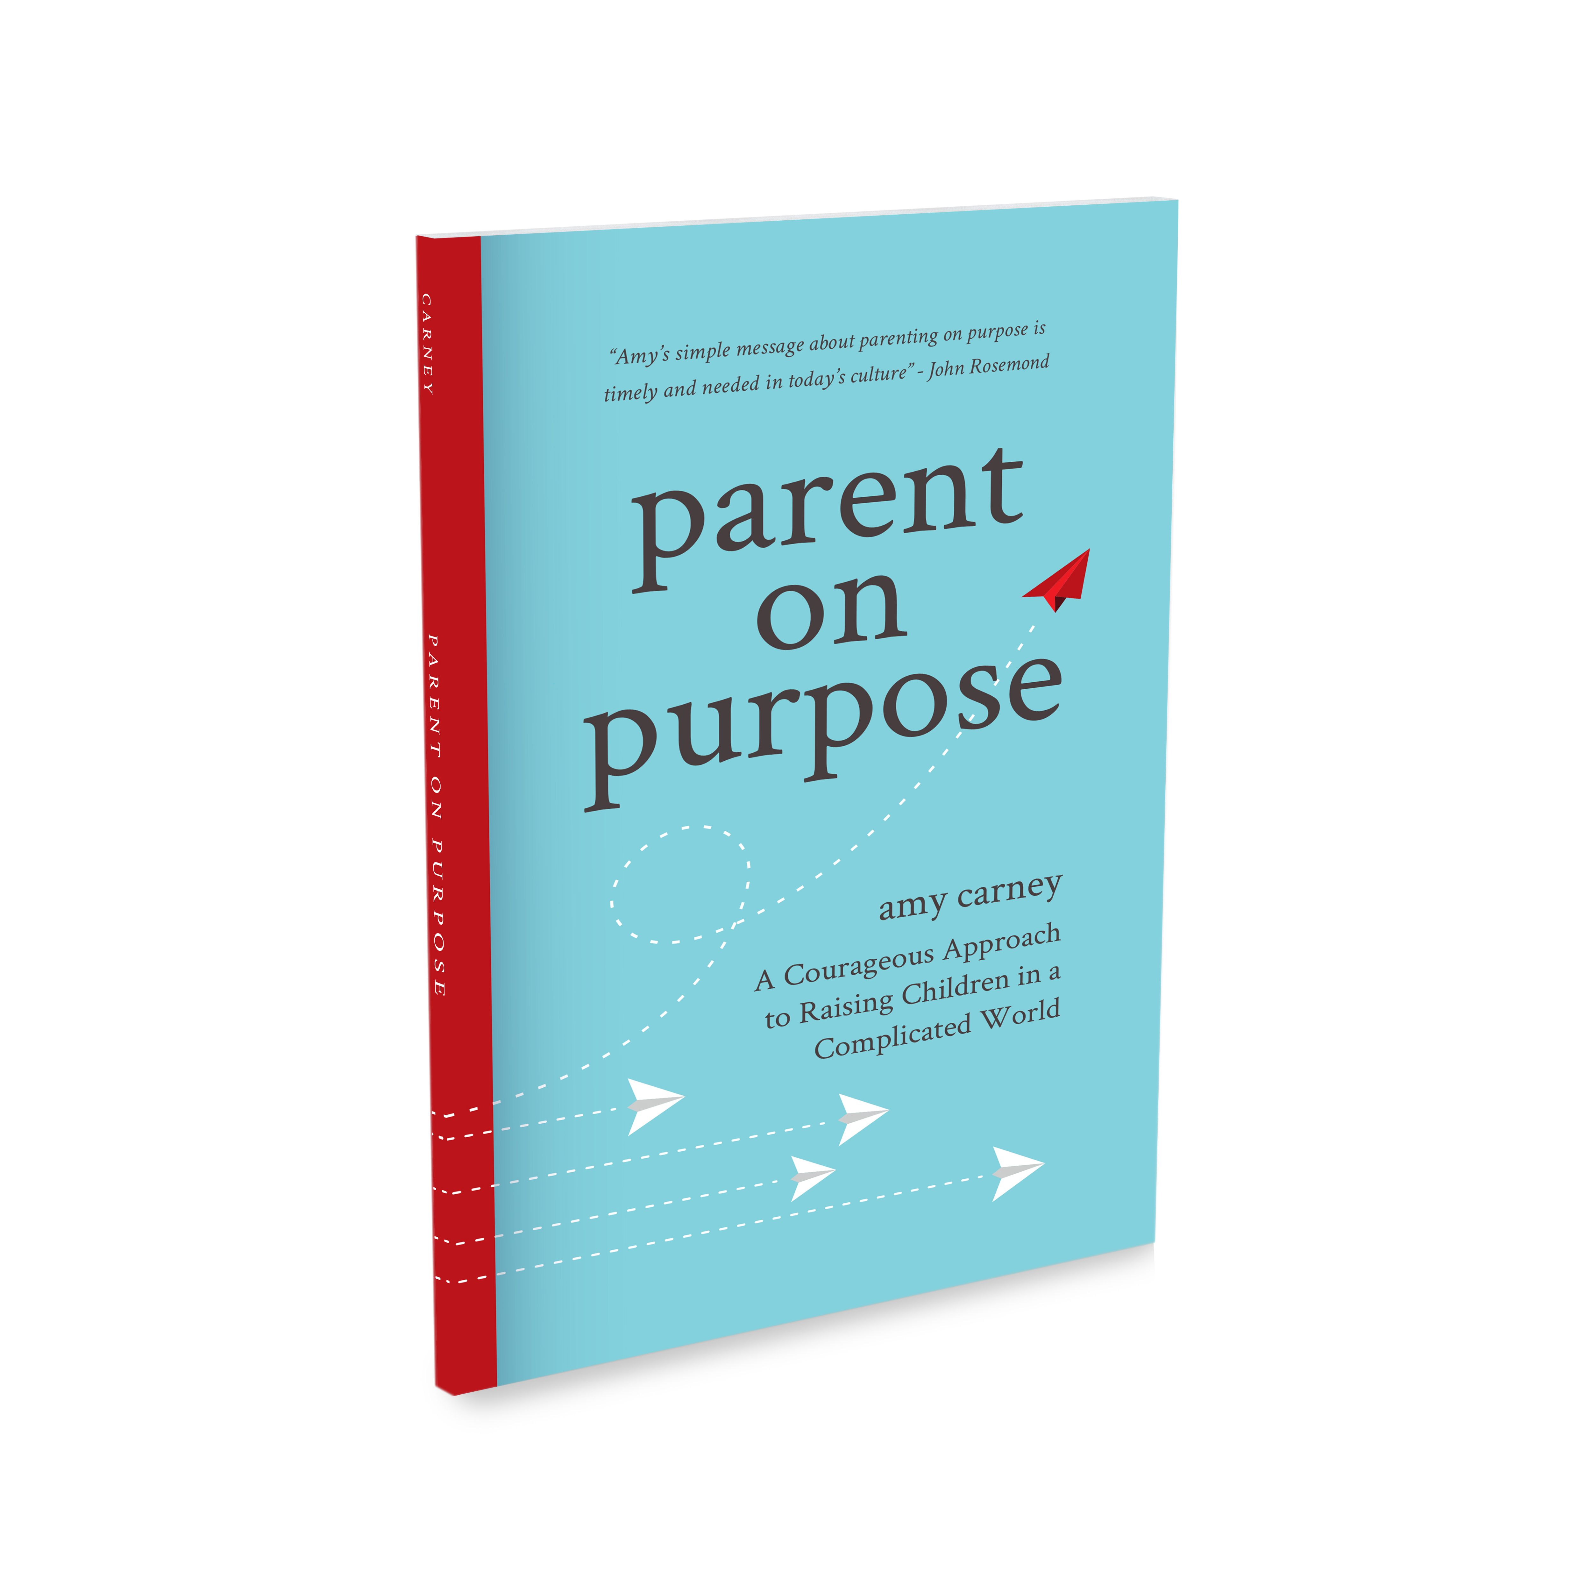
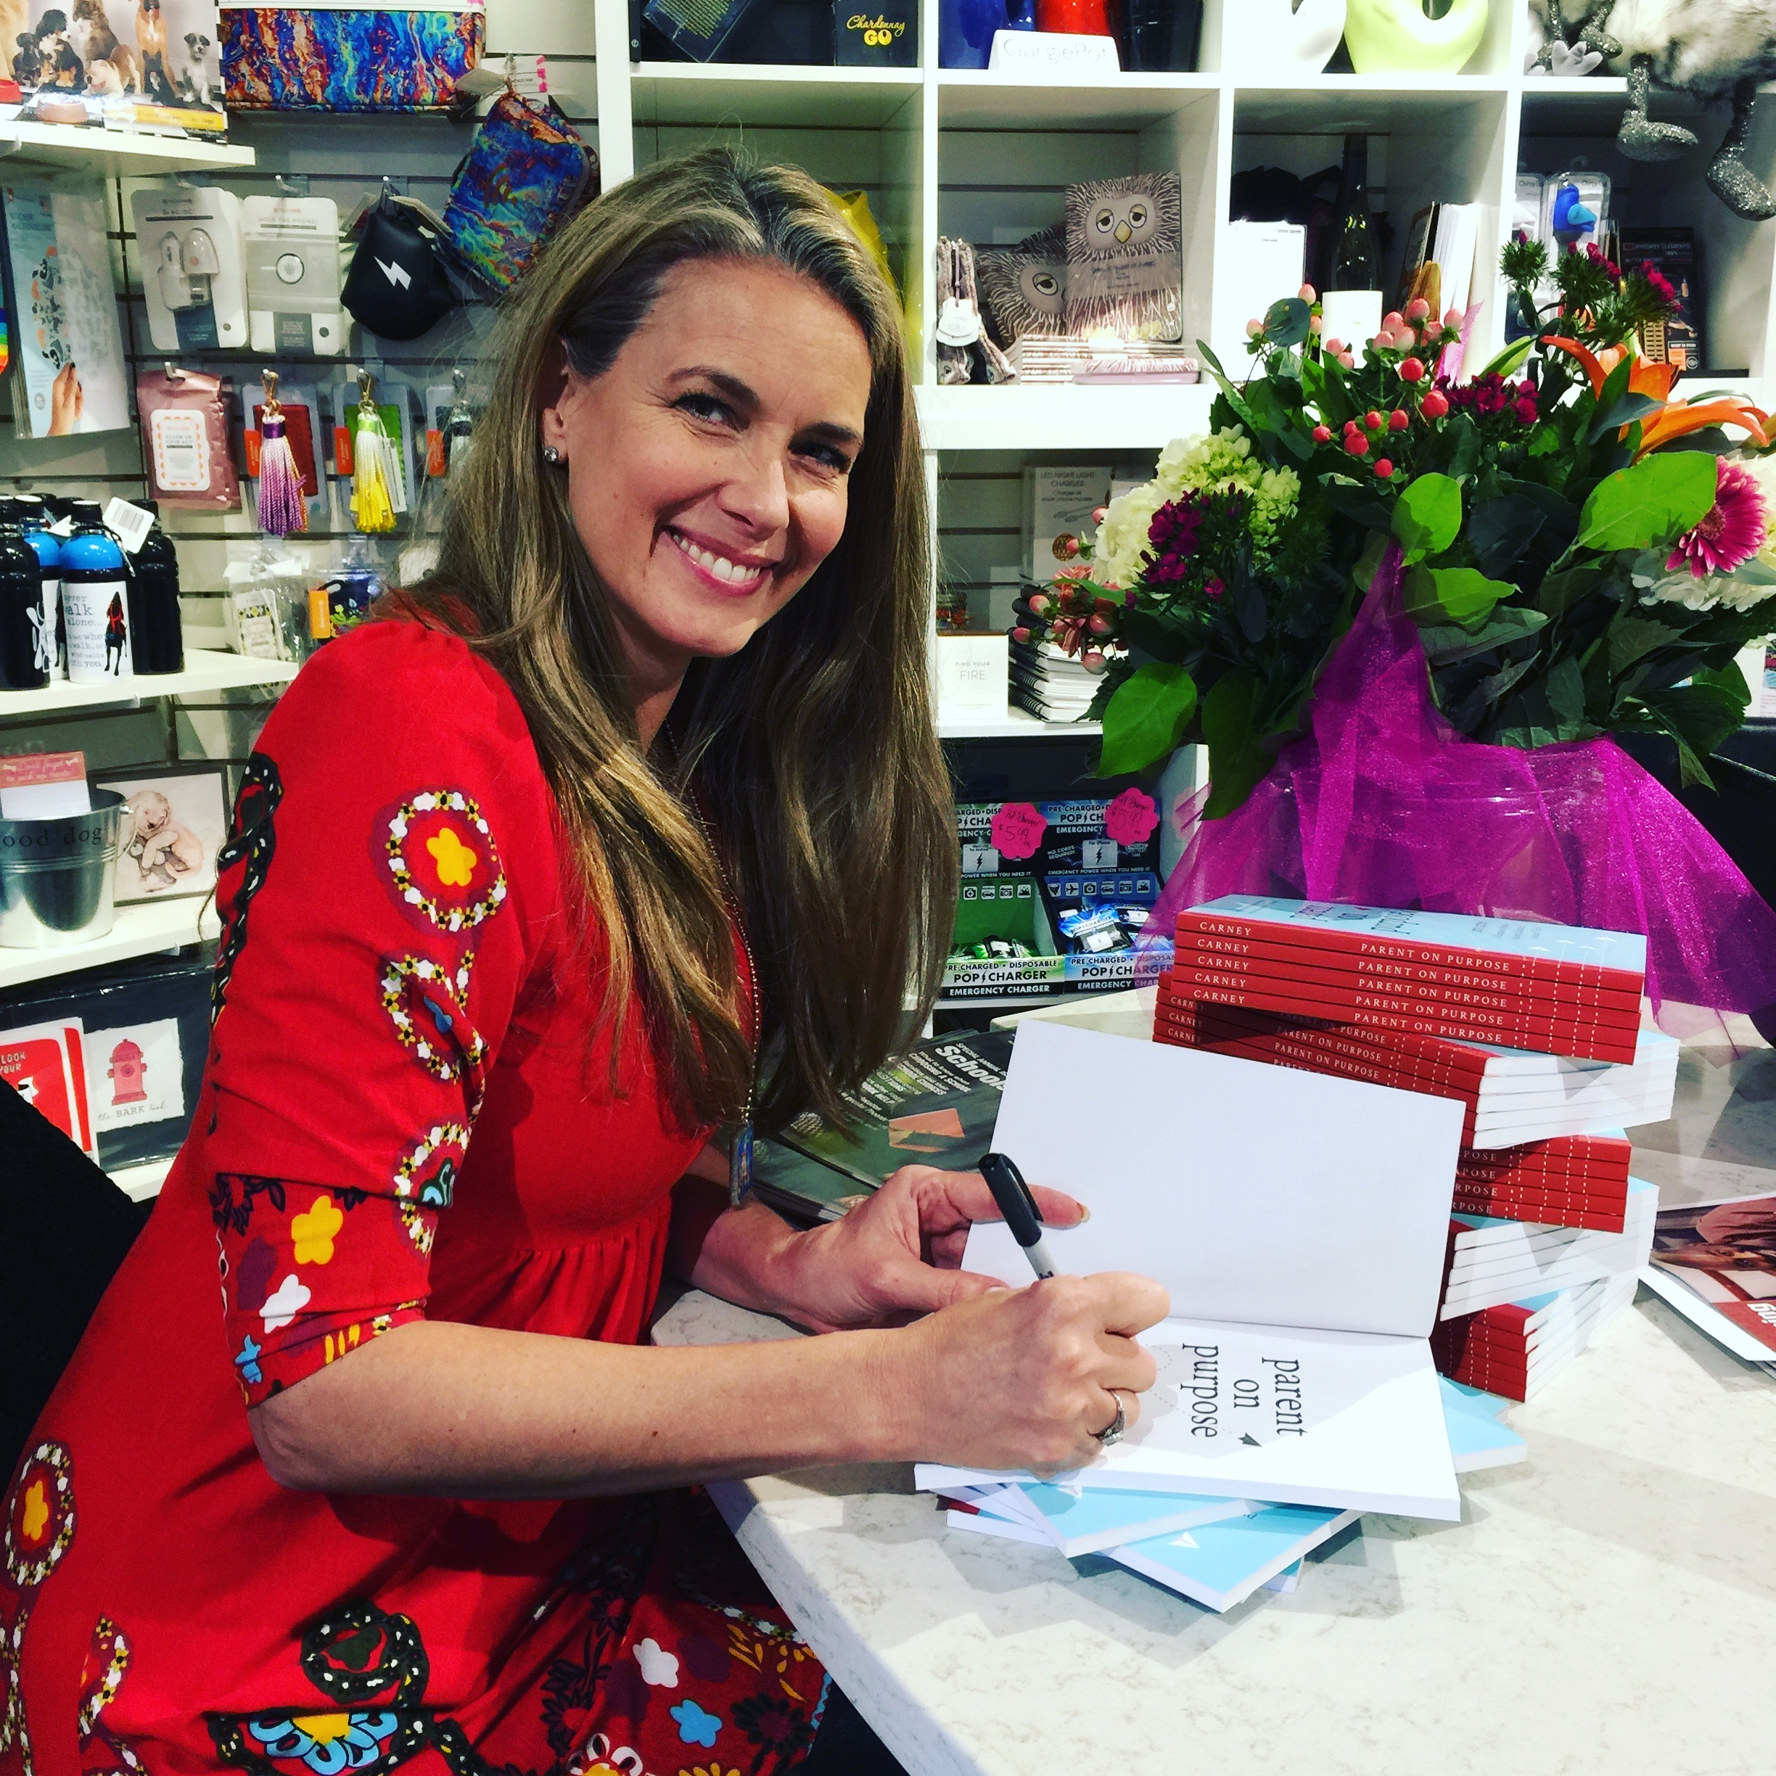
Amy and her husband of 22 years, Keith, are parents to 18-year-old triplet sons, a 16-year-old daughter and a 13-year-old son they adopted from the Arizona foster care system three years ago.

